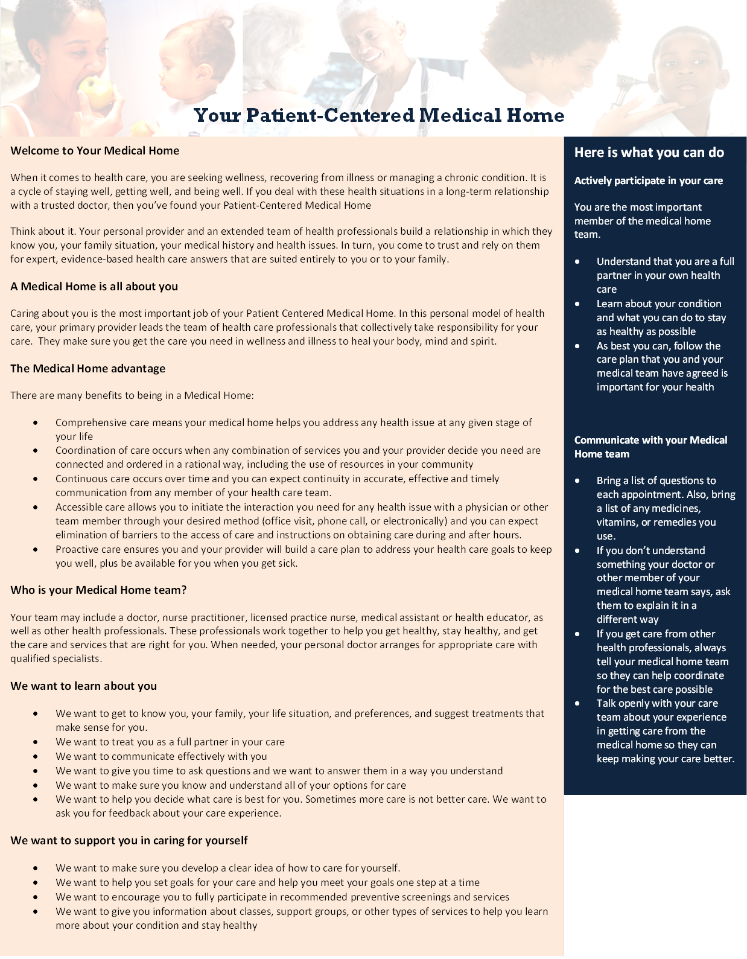

South County Pediatric Associates, PC

13303 Tesson Ferry Rd.

Suite 35

Saint Louis, MO 63128

P: 314.849.3320

F: 314.849.7766

[www.socopeds.com](http://www.socopeds.com)

After Hours: 314.849.5770